Dear Researchers and Clinical Users,
To maintain accuracy and ensure proper attribution in your publications, it is crucial that Akern's bioimpedance technologies are cited correctly in any peer-reviewed journal or clinical report. A proper citation avoids any misinformation or misattribution of the ownership and application of our bioimpedance tools.
Please make sure to use the following guidelines when referencing Akern's technologies:
- Device and Software Name: Clearly mention the specific Akern device and software used (e.g. BIA 101, Bodygram HBO, NUTRLAB) in the methodology section of your paper.
- Citation Format: Refer to any official documentation, technical specifications or validation studies associated with Akern devices. Include the most relevant studies and sources that verify the technology's accuracy and intended use.
- Avoid Misattribution: Ensure that any conclusions or applications are directly linked to the correct Akern technology. Misattributing bioimpedance technology to other methods or companies can lead to confusion and misinformation in the field.
Your cooperation is appreciated to maintain the integrity of scientific communication involving bioimpedance technology.
Revision status: 5
Date: 09/12/2024
TABLE OF CONTENTS
Device model | Life cycle | How to cite the technology in the “Material and method” paragraph | Technology (current, frequency, resolution, CV%)
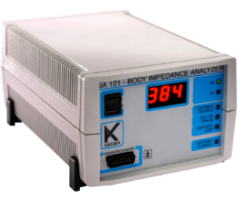  BIA 101 | 1998  Up to 2009 | Whole body bioimpedance (BIA 101 AKERN, Florence, Italy) was performed using an alternating sinusoidal electric current of 800 microampere at an operating frequency of 50 kHz. The calibration of the device was checked each day measurements were performed, always at the first measurement of the day, using the standard control circuit supplied by the manufacturer with a known impedance [resistance (R) = 380 Ohm; reactance (Xc) = 47 Ohm]. The accuracy of the device was 1% for R and 2% for Xc. For the BIA measurement, each participant was supine with limbs slightly spread apart from the body. Disposable tab electrodes (BIATRODES Akern Srl; Florence, Italy) were placed on the right side at metacarpal and metatarsal sites of the right wrist and ankle [a]. | 800 µA current at  50 kHz (±2%), resolution Rz: ±1%, Xc: ±2%,  CV% <3,5%
BIA 101 New Edition  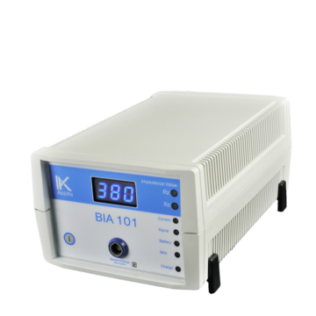 | 2010  Up to 2019 | Whole body bioimpedance (BIA 101 new edition AKERN, Florence, Italy) was performed using an alternating sinusoidal electric current of 400 microampere at an operating frequency of 50 kHz. The device was calibrated every morning using the standard control circuit supplied by the manufacturer with a known impedance [resistance (R) = 380 Ohm; reactance (Xc) = 47 Ohm]. The accuracy of the device was 1% for R and 2% for Xc. For the BIA measurement, each participant was supine with limbs slightly spread apart from the body. Disposable tab electrodes (BIATRODES Akern Srl; Florence, Italy) were placed on the right side at metacarpal and metatarsal sites of the right wrist and ankle [a]. | 400 µA current at  50 kHz (±1%), resolution Rz: ±1%, Xc: ±2%,  CV% <2,8%
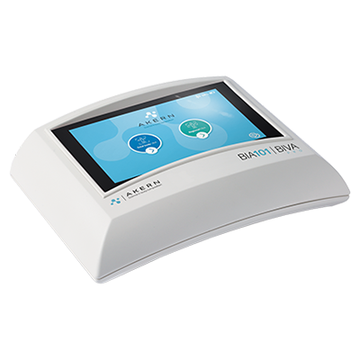  BIA 101 BIVA | 2019 up to 10/2020 | Whole body bioimpedance (BIA 101 BIVA AKERN, Pisa, Italy) was performed by a phase sensitive device working with alternating sinusoidal electric current of 250 microampere at an operating frequency of 50 kHz (±1%). The device was calibrated every morning using the standard control circuit supplied by the manufacturer with a known impedance [resistance (R) = 380 Ohm; reactance (Xc) = 42 Ohm]. The accuracy of the device was 0.1% for R and 0.1% for Xc. For the BIA measurement, each participant was supine with limbs slightly spread apart from the body. Very low intrinsic impedance (<30 Ohm) disposable electrodes (BIATRODES Akern Srl; Florence, Italy) were placed on the right side at metacarpal and metatarsal sites of the right wrist and ankle [a]. | 250 µA current at  50 kHz (±1%), resolution Rz: ±1%, Xc: ±1%,  CV% <1%
BIA 101 BIVA PRO  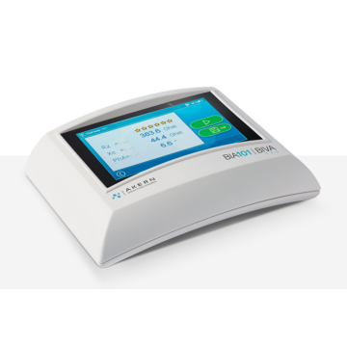 | 01/2021 - Today | Whole body configuration:  Bioimpedance analysis was performed by a phase sensitive device (BIA 101 BIVA PRO AKERN srl, Pisa, Italy) working with alternating sinusoidal electric current of 245 microampere at an operating frequency of 50 kHz (±1%). The device was calibrated every morning using the standard control circuit supplied by the manufacturer with a known impedance [resistance (R) = 380 Ohm; reactance (Xc) = 45 Ohm]. The accuracy of the device was 0.1% for R and 0.1% for Xc. For the BIA measurement, each participant was supine with limbs slightly spread apart from the body. Very low intrinsic impedance (<30 Ohm) disposable electrodes (BIATRODES Akern Srl; Florence, Italy) were placed on the right side at metacarpal and metatarsal sites of the right wrist and ankle [a].  Regional configuration:  Bioimpedance analysis was performed by a phase sensitive device (BIA 101 BIVA PRO AKERN srl, Pisa, Italy) working with alternating sinusoidal electric current of 245 microampere at an operating frequency of 50 kHz (±1%). The device was calibrated every morning using the standard control circuit supplied by the manufacturer with a known impedance [resistance (R) = 345 Ohm; reactance (Xc) = 32 Ohm for left sensing channel and resistance (R) = 380 Ohm; reactance (Xc) = 45 Ohm for the right sensing channel].  The resolution of the device was 0.1 Ω for Rz and 0.1 Ω for Xc in the full range of measurements.  For the regional bioimpedance measurement, each participant was supine with limbs slightly spread apart from the body. Very low intrinsic impedance (<30 Ohm) disposable electrodes (BIATRODES Akern Srl; Florence, Italy) were placed on both side of the body at metacarpal and metatarsal sites of the right and left wrists and ankles [c]. | 245 µA current at  50 kHz (±1%),  Accuracy :  Rz: ±0.1,Ω  Xc: ±0.1 Ω  CV% <1%
NUTRILAB  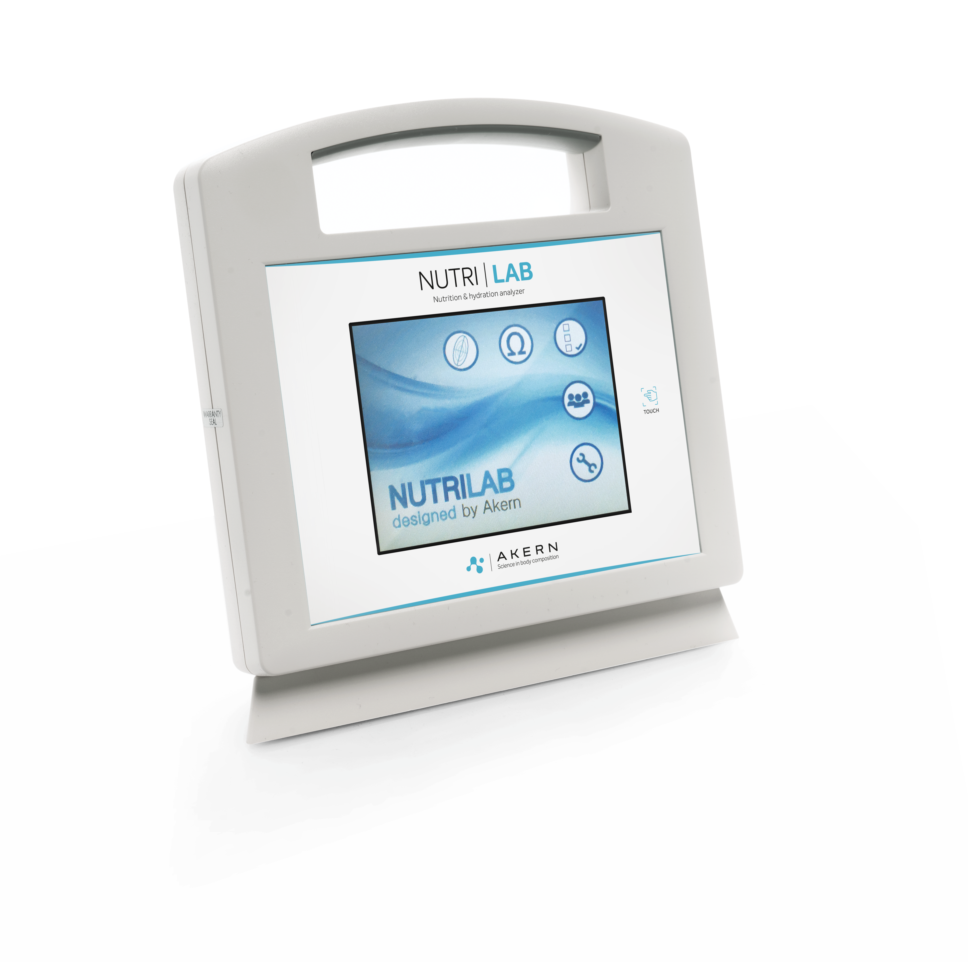 | 2014- Today | Bioelectrical impedance was measured with a phase-sensitive touch screen impedance device (Nutrilab, Akern, Florence, Italy), working with alternating sinusoidal electric current of 245 microampere at an operating frequency of 50 kHz (±1%). The device was calibrated every morning using the standard control circuit supplied by the manufacturer with a known impedance resistance (R) = 380 Ohm; reactance (Xc) = 45 Ohm.  Impedance data are shown directly in a LCD touchscreen and stored into an internal memory. The inter observer CV% , evaluated in this healthy cohort is below 2%. | Serial number 2014-2019 :  425 µA current at  50 kHz (±0.1%), resolution Rz: ±0.1%, Xc: ±0.1%,  CV% <2%  Serial number > 2019 245 µA current at  50 kHz (±1%),  Accuracy :  Rz: ±0.1,Ω  Xc: ±0.1 Ω  CV% <1%
BIA 101 Anniversary  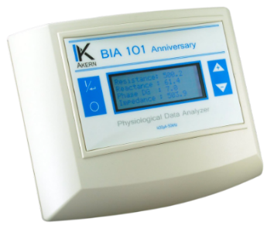 | 2010-2020 | Whole-body impedance (BIA 101 Anniversary, Akern, Florence, Italy) is generated in soft tissues to oppose the ﬂow of an injected alternate current and is measured from skin Ag/AgCl electrodes placed at fixed-distance (5 cm) on the hands and feet. The device generates an alternating sinusoidal electric current of 400 microamperes at an operating single frequency of 50 kHz (±0.1%). Resistance (R, Ω) is the opposition to the ﬂow of an injected alternating current through intra and extracellular ionic solutions, while reactance (Xc, Ω) is the dielectric or capacitive component of cell membranes and organelles, and tissue interfaces. | 425 µA current at  50 kHz (±0.1%), Resolution Rz: ±0.1%, Xc: ±0.1%, CV% <2%
CARDIOEFG -RENALEFG  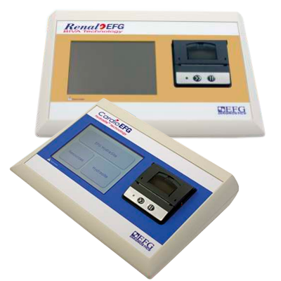 | 2009 -2018 | Bioimpedance vector analysis using tetrapolar impedance plethysmography that emitted 50 kHz alternating sinusoidal current (CardioEFG, Akern, Florence, Italy) of 400 microamperes. Resistance (R, Ω) is the opposition to the ﬂow of an injected alternating current through intra and extracellular ionic solutions, while reactance (Xc, Ω) is the dielectric or capacitive component of cell membranes and organelles, and tissue interfaces.  Data are shown directly in a LCD touchscreen and stored into an internal memory. The CV% was evaluated in (_) patients: the mean coefﬁcients of variation for both parameters were 0.5% intra-patient and 1.6% inter-operator. Disposable proprietary low impedance electrodes (BIVATRODES Akern Srl; Florence, Italy) were placed on the right side at metacarpal and metatarsal sites of the right wrist and ankle [a]. | 400 µA current at  50 kHz (±1%), Resolution Rz: ±0.1%, Xc: ±0.1%, CV% <2%
EFG v.3  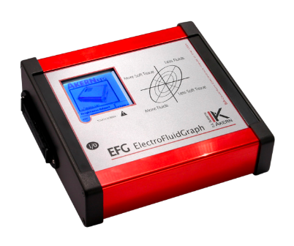 | 2005-2010 | Whole-body impedance data were obtained using a tetrapolar impedance plethysmography (EFG V.3 Akern, Florence, Italy). The bioelectrical parameters of resistance and reactance were measured using an electric alternating current flux of 400 amperes and an operating frequency of 50 kHz. Whole-body impedance measurements were taken according to the standard protocol of Lukaski et al [a]. | 400 µA current at  50 kHz (±2%), Resolution Rz: ±1%, Xc: ±1%, CV% <2%
BIATRODES  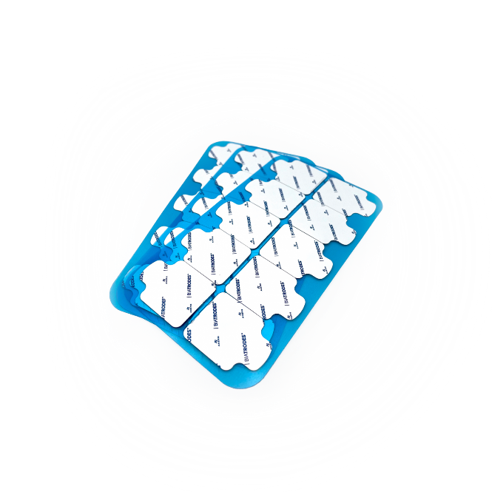 | 1998- Today | Two pairs of adhesive Ag/AgCl low impedance electrodes (BIATRODES Akern Srl; Florence, Italy) were placed proximal to the phalangeal–metacarpal joint on the dorsal surface of the right hand and distal to the transverse arch on the superior surface of the right foot. Sensor electrodes were placed at the midpoint between the distal prominence of the radius and ulna of the right wrist, and between the medial and lateral malleoli of the right ankle at a fixed distance of 5 cm each other.
BIVATRODES   | 2012- Today | Two sets adhesive Ag/AgCl low impedance electrodes (BIVATRODES Akern Srl; Florence, Italy), designed for accurate and sensitive bioimpedance measurements were placed proximal to the phalangeal–metacarpal joint on the dorsal surface of the right hand and distal to the transverse arch on the superior surface of the right foot. Sensor electrodes were placed at the midpoint between the distal prominence of the radius and ulna of the right wrist, and between the medial and lateral malleoli of the right ankle.
Bodygram 1.31 | 1998 | EOL (End of Life) | na
Bodygram PRO | 2008 | EOL (End of Life)
Bodygram plus | 2014 | EOL (End of Life)
Bodygram™ Dashboard | 2020-today | Cloud based software for body composition components estimation and graphical representation of the parameters.
Bodygram™ HBO | 2020-today | Stand alone, multi users, GDPR compliant software for body composition components estimation and graphical representation of the parameters.

MATERIAL and METHOD: sample paragraph
The impedance measurements were performed with a phase sensitive single frequency analyzer (MODEL () , Akern srl, Italy), which applies an alternating current of (___) µA at the frequency of 50 kHz. Measurements were made using tetrapolar configuration as described by Lukaski (1986) [a].
The subjects were in the supine position with a leg opening of 45° compared to the median line of the body and the upper limbs positioned 30° away from the trunk. After cleansing the skin with isopropyl alcohol, two Ag/AgCl very low-impedance electrodes (Biatrodes, Akern Srl, Florence, Italy) were placed on the back of the right hand and two electrodes on the corresponding foot, with a distance of 5 cm between each other [b].
To avoid disturbances in fluid distribution, the subject was instructed to abstain from food and drink for >4 h before the test [c] [d].

[a] Lukaski, Henry C., et al. "Validation of tetrapolar bioelectrical impedance method to assess human body composition." Journal of applied physiology 60.4 (1986): 1327-1332.

[b] Dunbar, Christopher C., et al. "Effects of small errors in electrode placement on body composition assessment by bioelectrical impedance." Research quarterly for exercise and sport 65.3 (1994): 291-294.

[c] Kushner, Robert F., Rani Gudivaka, and Dale A. Schoeller. "Clinical characteristics influencing bioelectrical impedance analysis measurements." The American journal of clinical nutrition 64.3 (1996): 423S-427S.

[d] Slinde, Frode, and Lena Rossander-Hulthén. "Bioelectrical impedance: effect of 3 identical meals on diurnal impedance variation and calculation of body composition." The American journal of clinical nutrition 74.4 (2001): 474-478.

